MIE Greenbook Database

Developer: [masudahmed.cuet@gmail.com](mailto:masudahmed.cuet@gmail.com)

Contents

Running The Database 4

1.1 Security Warning. File is blocked. 5

1.2 Unblock the file, in properties. 6

1.3 Unblock the file, in properties. Continued. 7

2. Enablel Contents 8

2.1 Enable Contents, macros, queries 9

3. Student Form 10

3.1 Student form 11

3.2 Change between Students 12

4. Add and View Gradesheet 13

4.1 Gradesheet 14

4.2 Gradesheet View 15

4.3 Add Gradesheet Procedure 16

4.4 View Courses inside Registered gradesheet 17

5. Add and View Course and Result 18

5.1 Add Course 19

5.2 Select Result Grade 20

6. Print Gradesheet Section 21

6.1 Choose Section 22

6.2 View Gradesheet Sections 23

6.3 Print 24

The End 25

# Running The Database

N.B: Access database is a powerful application. So use at your own risk. Also make sure you downloaded the file from trusted source. If possible, download from developer and check file hash for integrity.

## 1.1 Security Warning. File is blocked.

1. You need Microsoft Access software installed, to run this database.
2. As you download the database from internet, you might need to unblock the file

## 1.2 Unblock the file, in properties.

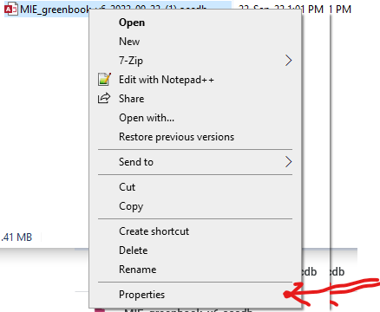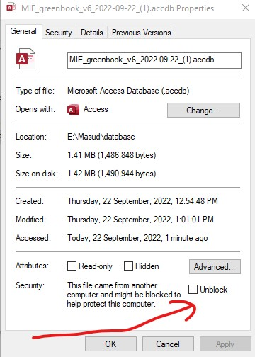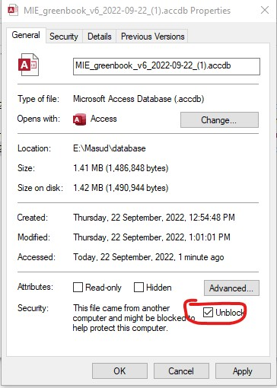

## 1.3 Unblock the file, in properties. Continued.

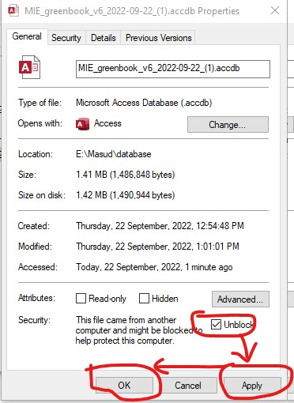

# 2. Enablel Contents

## 2.1 Enable Contents, macros, queries

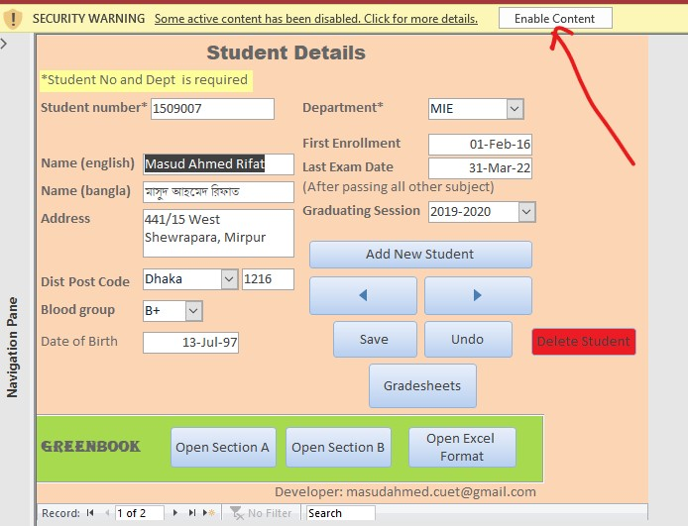

# 3. Student Form

## 3.1 Student form

1. 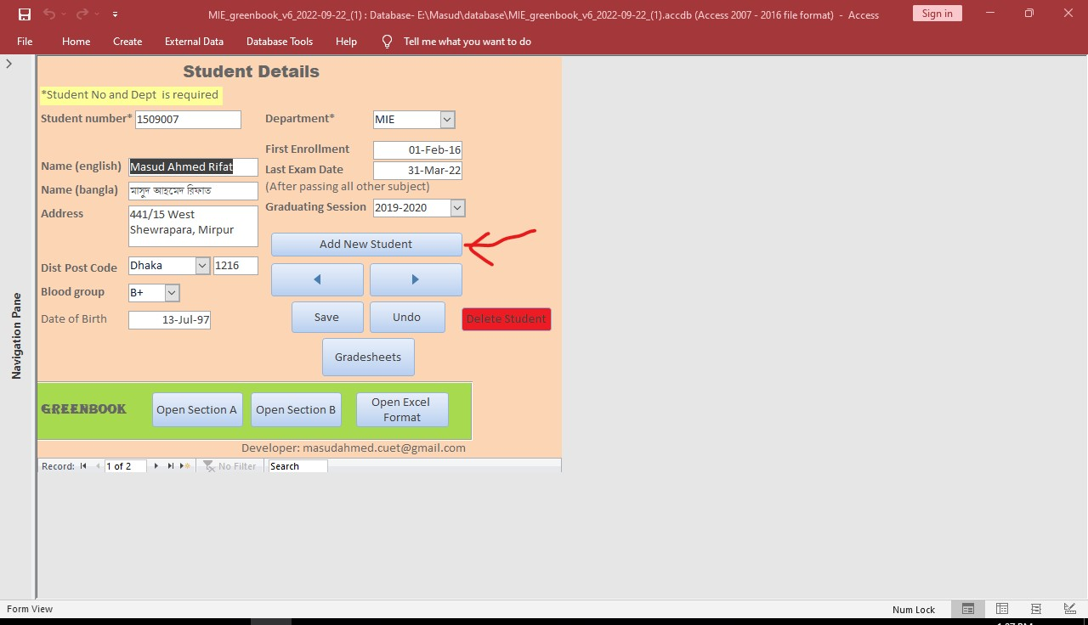On start, "Student details" form will be opened.
2. In this form, select "add new student". This will show blank form
3. In this form, you can add, edit and delete student.
4. Student number and department; this 2 info is required to create a new student.

## 3.2 Change between Students

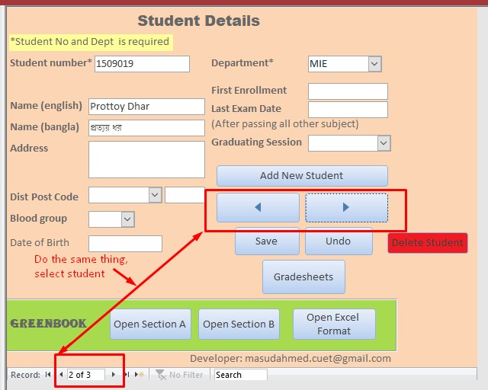

# 4. Add and View Gradesheet

## 4.1 Gradesheet

1. After Entering and saving student info. You can open gradesheets for that student.
2. Click "gradesheets". This will open another form. In this form, from the upper most section

## 4.2 Gradesheet View

1. 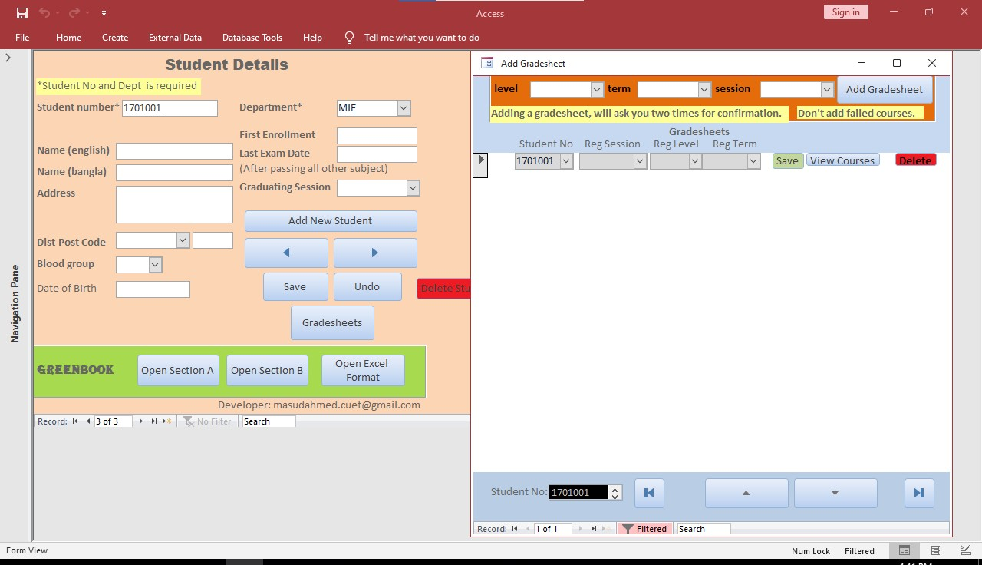The Gradesheet window on the right, can be moved and resized for convenience.
2. It is necessary to add new gradesheet here, according to the actual gradesheets; that you receive from versity. By this way, your Greenbook will be correctly filled up.

## 4.3 Add Gradesheet Procedure

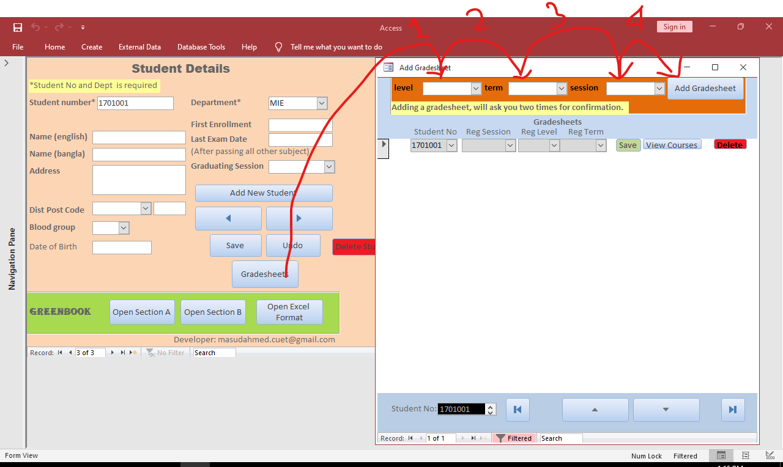

## 4.4 View Courses inside Registered gradesheet

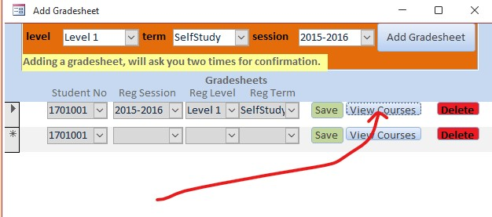

# 5. Add and View Course and Result

## 5.1 Add Course

1. 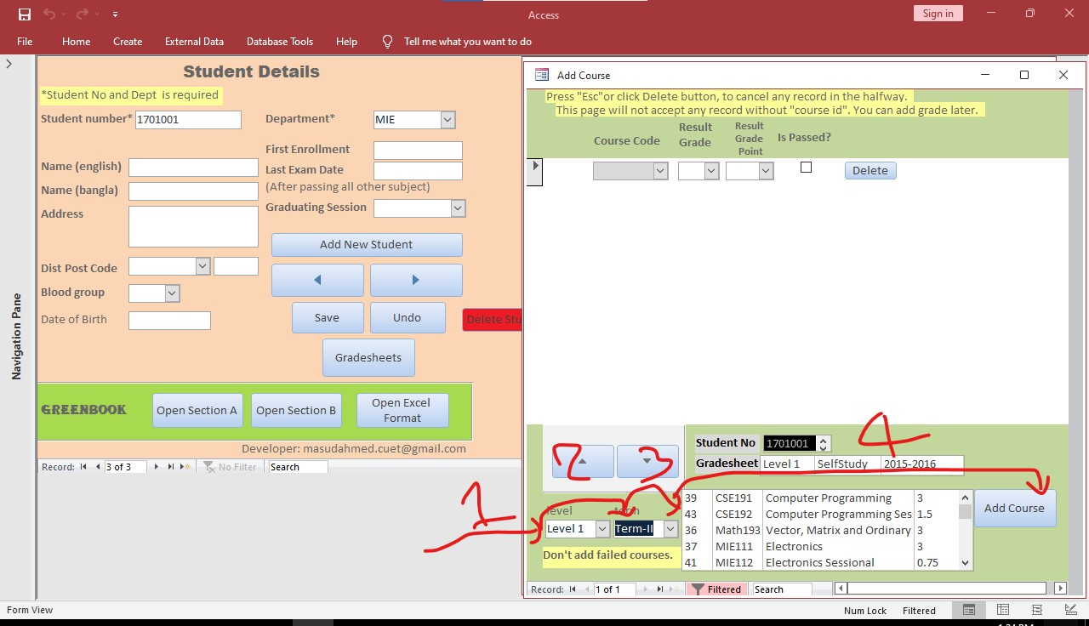Add Courses one by one in your gradesheet.
2. In the lower section, first select level. Then select term. This will populate courses of that level-term.
3. Select one course and click “add course button”.
4. For easy finding, course codes are sorted alphabetically.

## 5.2 Select Result Grade

1. You can select either letter grade or point grade as your result. One will automatically populate the other.

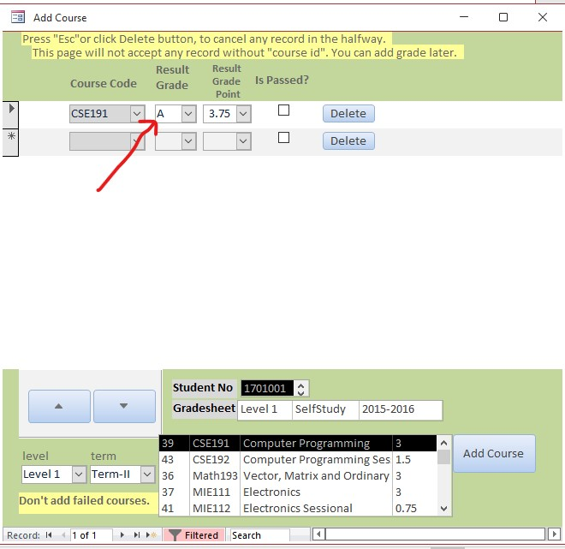

1. It is good to select the check mark “is passed”. Currently it is not used, but can be used in future for logic.

# 6. Print Gradesheet Section

## 6.1 Choose Section

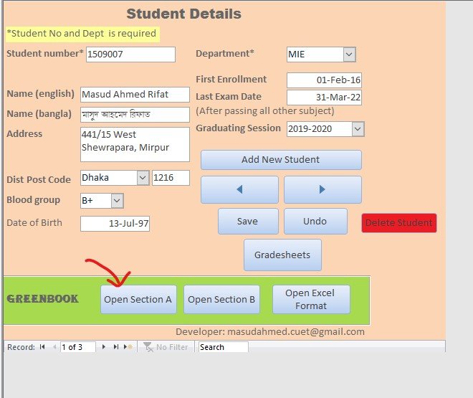

## 6.2 View Gradesheet Sections

* 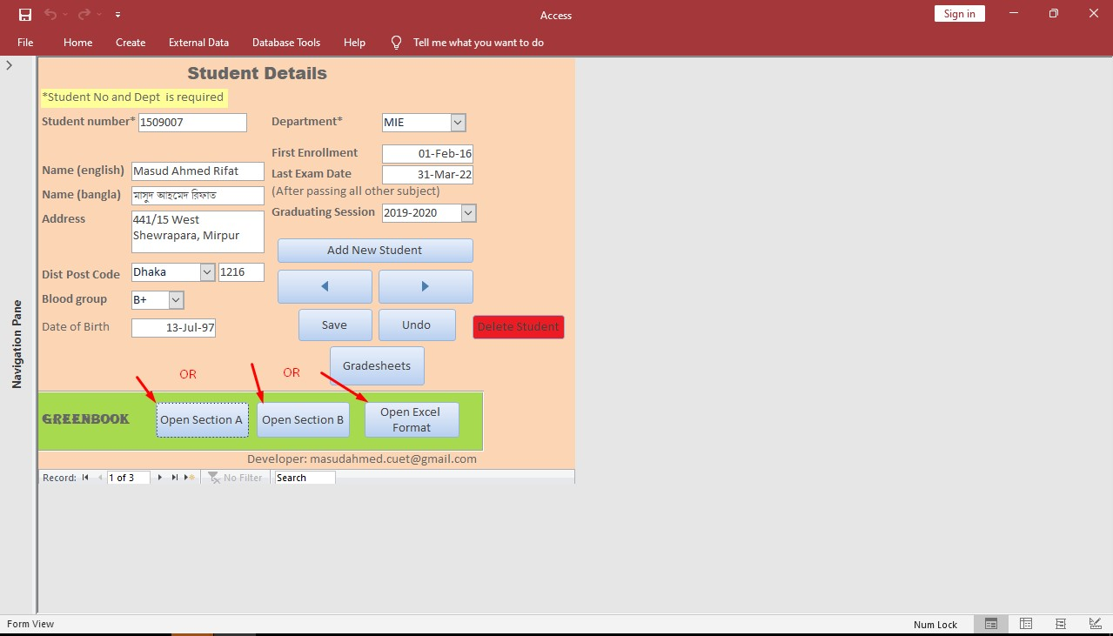There are three buttons in the lower portion.
* Each button prints in different format as of greenbook.

## 6.3 Print

1. After opening print preview of greenbook, you can click on it to zoom in.

Click to zoom

Print options,

pdf options

# The End